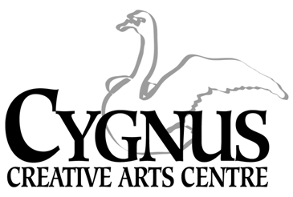
5045 English Creek Avenue, Egg Harbor Township, NJ 08234
609.272.1199 / fax:609.272.1935
www.cygnusarts.org / email: info@cygnusarts.org

Art in Motion (A.I.M.) Program
Application
Student
First Name: _____________________________________ Last Name:_________________________________________

Student School:______________________________________ Student Grade:__________________________________

Parent/Guardian
First Name: ______________________________________Last Name: ________________________________________

Address: __________________________________________State: _________________Zip:_______________________

Cell Phone: _________________________________Email: __________________________________________________

This program is after school for 15 wks for Session I and 17 wks for Session II. There are no make-up days for missed class.
Registration is First Come, First Served basis. All Students Must Register for One (1) Session and One (1) Day.
Please choose 1 (One) Day and 1(One) Session
MONDAYS 4:15pm-6:15pm Session I / September 11- December 18, 2023
Session II / February 5- June 7, 2024

FRIDAYS 4:15pm-6:15pm Session I / September 8-Decmeber 22, 2023. No Class Nov. 23
Session II / February 9- June 7, 2024
Complete this form and Email to: info@cygnusarts.org or Fill out the Google Forms: https://forms.gle/FEymSXH7jHBSBJRA7 cut and paste this to your browser.
- Program is Limited to 30 Students on Mondays and 30 Students on Fridays.
- 1st and 2nd Grade Students are Eligible. Proof of age and grade level are required.
- All parents or guardians will be responsible for all transportation to and from Cygnus Creative Arts Centre. Please arrive on time to pick up your child.
- All parents agree to attend the parent/guardian orientation meeting Wednesday August 30 at 6:00pm.
- Failure to attend this meeting results in the surrender of this application.
WAIVER
I certify that my child or myself is in good health and capable of participating in all activities and classes. I hereby release and forever discharge Cygnus Creative Arts Centre, any employees, teachers or Board of Directors members from any and all claims, demands, rights or cause of actions whatsoever kind of nature, arising from or by any reason of any and all known or unknown, foreseen, or unforeseen bodily or personal injuries and the consequences thereof.
Parent/Guardian PRINT Name:______________________________________________________________
Parent/Guardian signature: _________________________________________________________________
Media Waiver: All students are subject to be photographed or videoed for studio purposes only. No photographs or videos will ever be used or sold for any purpose other than use for marketing tools. Photographs and videos may appear on the website and social media once approved by the organization.
Parent / Guardian PRINT Name: ____________________________________________________________________
Parent / Guardian Signature: _____________________________________________________________________

