Cygnus Creative Arts Centre
5045 English Creek Avenue, Egg Harbor Township, NJ 08234-5243
(609) 272.1199 / (609) 272.1935 fax
www.cygnusarts .org / info@cygnusarts.org

Art in Motion / The A.I.M. Program

This is an exciting Outreach Program sponsored by Cygnus Creative Arts Centre.
The program is intended for students in 1st and 2nd grade, focusing the understanding and participation of dance as a moving art form. The program design holds weekly classes after school, in classical ballet, modern and jazz dance, providing an arts education to those who do not have the opportunity, economic means or familiar connections to participate in the art of dance. This program serves the disadvantaged youth in the community at large.
Art in Motion (A.I.M) is- free of charge, and made possible by funds from the Atlantic County Office of Cultural and Heritage Affairs, a partner of the New Jersey Counsel on the Arts.

A.I.M. Strives to:
•Support and advance young emerging artists through instruction and performances.
•Enable access to Cygnus’s visual and performing arts studios and provide students performance and exhibition space for student presentations.
•Provide quality arts education to underserved students of all ages and abilities.
•Produce programs that introduce audiences and community members to a wide spectrum of art forms that include local and regional youth guest artists.
•Offer programs that engage minds, thus improving cognitive skills, cultivate creativity, encourage participation, promote interdisciplinary dialogue and tolerance though meaningful links between classmates, artists and the community.
•Foster arts literacy and advocate for the arts as an essential component of the cultural vitality of our city and surrounding communities.
- Support Social, Emotional, Learning (SEL) to include: building social-emotional skills and attitudes, increase school day attendance, develop positive social behavior, build confidence, self worth and esteem, create and improve relationships between students and increase academic achievement, thus raising graduation rates.
- All students learn invaluable working skill sets through direct participation in the arts.

Program Details
- Classes are held after school Mondays and Fridays 4:15-6:15pm.
- Parents are required to provide their own transportation to and from Cygnus.
- Session I begins September 11, 2023 – December 18, 2023.
- Sessions II begins February 5- June7, 2024 and concludes with end of year dance concert.
- Program is Limited to 30 Students on Mondays and 30 Students on Fridays.
- 1st and 2nd Grade Students are Eligible. Proof of age and grade level are required.
All Students Must Register for One (1) Session and One (1) Day.
Registration is First Come, First Served basis. Register through Google Doc QR code.
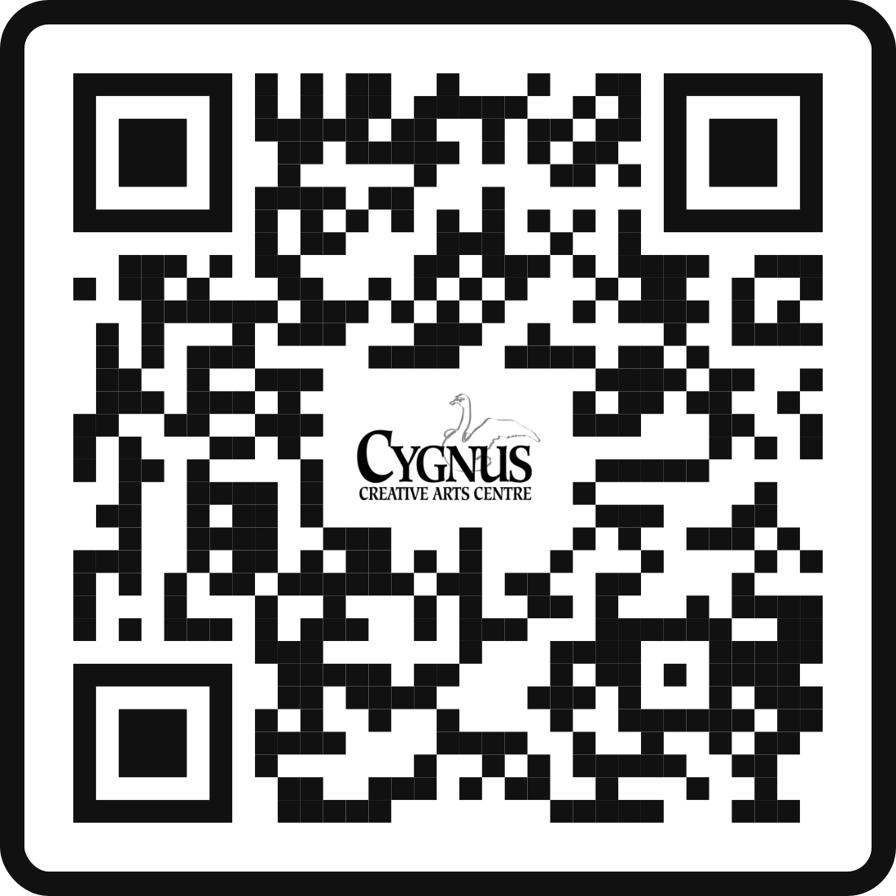
Parents who register will attend a Parent Meeting Wednesday August 30, 2023 6:00pm.
Any Parent who does Not Attend forfeits their Child’s Registration. Please send someone in your place.

Cygnus Creative Arts Centre is located in the
Egg Harbor Township Community Centre located at 5045 English Creek Avenue, Egg Harbor Township, NJ.
Art in Motion (A.I.M) is- free of charge, and made possible by funds from the Atlantic County Office of Cultural and Heritage Affairs, a partner of the New Jersey Counsel on the Arts.

Officers
Kenneth Hitchens
President

Pamela M. Tyson
Vice President

Janet Rosenthal
Treasurer

Janice Cambron
Secretary

Artistic Director

Cynthia M. Domino

Directors

Paul Herron
Mark Kadetsky
Tamar LaSure-Owens
Gary Press

